Printing ‘Activity’ from the website

Do you, like me, like to carry a copy of ‘Activity’ with me on my camping trips?
Obviously, it is not possible to walk around with my computer just to look up Activity!

First, download the Activity file from the website to a folder on your hard drive using the password that your area secretary emails you. This may be your ‘Downloads’ folder.
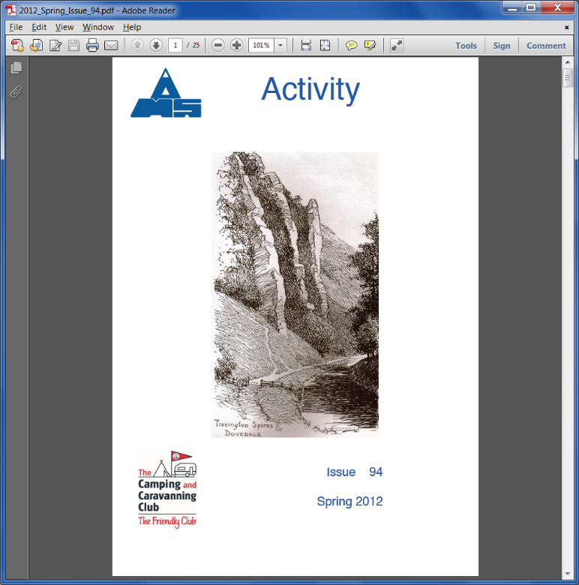
So, how do you now print out your own copy in colour?

To start you bring up Activity in ‘Adobe Reader’ from the folder on your computer which should look like this. This may occur automatically.

To start to print you can use one of 3 ways. Click on the printer icon on the toolbar, click on ‘File’ and then select Print, or use the Ctrl and P keys together. You should then have the ‘Print’ dialog box displayed.

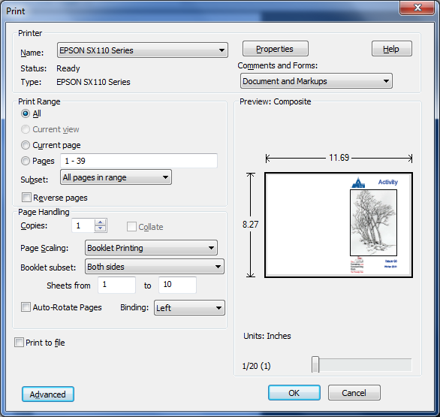
If you are using Adobe Reader version 9 follow the instructions below:

In this dialog box choose your printer, All pages and 1 copy.

For Page Scaling select
‘Booklet Printing’

For Booklet subset select
‘Both Sides’

For Binding select ‘Left’

On your first try change ‘Sheets from’ to ‘1 to 1’ and then select

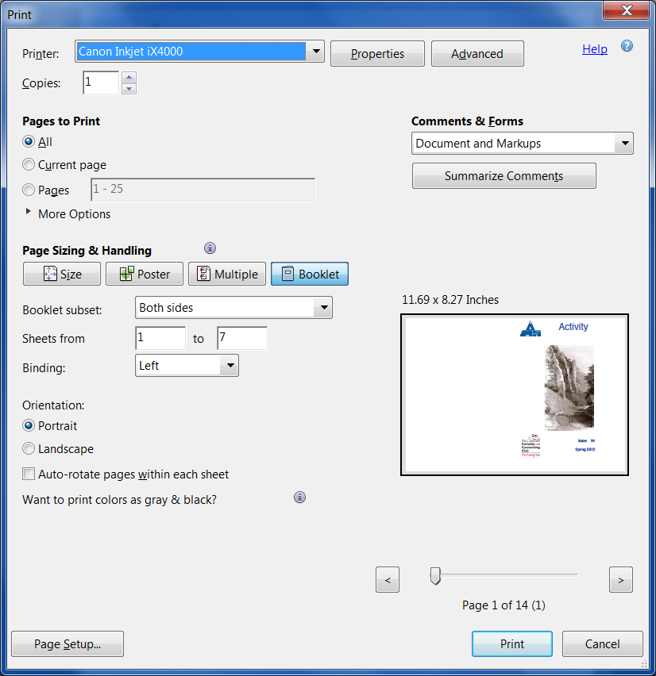
If you are using Adobe Reader version 10 follow the instructions below:

In this dialog box choose your printer, 1 copy and All pages.
Select

For Binding select ‘Left’

On your first try change ‘Sheets from’ to ‘1 to 1’ and then select

Not all printers are alike in the way they do double sided printing. You will have to experiment with your first sheet to ascertain which way to turn the paper when you put it back in the printer for the second side.

When you have succeeded with the first sheet, repeat the operation with ‘Sheets from’ with ‘2 to 2’ and then ‘3 to 3’, etc. Once you are practiced with this operation you may be able to do all the sheets in one go with ‘1 to 7’ or whatever the last sheet is.

Using 100-gram A4 paper produces a better result than the usual 80-gram. It does not bleed through to both sides. When you have printed all sheets, it is necessary to put them in order, fold the resulting booklet and staple them together.

Printing your own copy by using the website will help to reduce MAS costs, especially if you print copies for folk without computers. Those with black and white only printers will not be able to obtain the benefit of colour copies.

Note: If you are using an earlier version of Adobe Reader it should be possible to download a free update to one of the above versions.

